GIT BASH basic commands:

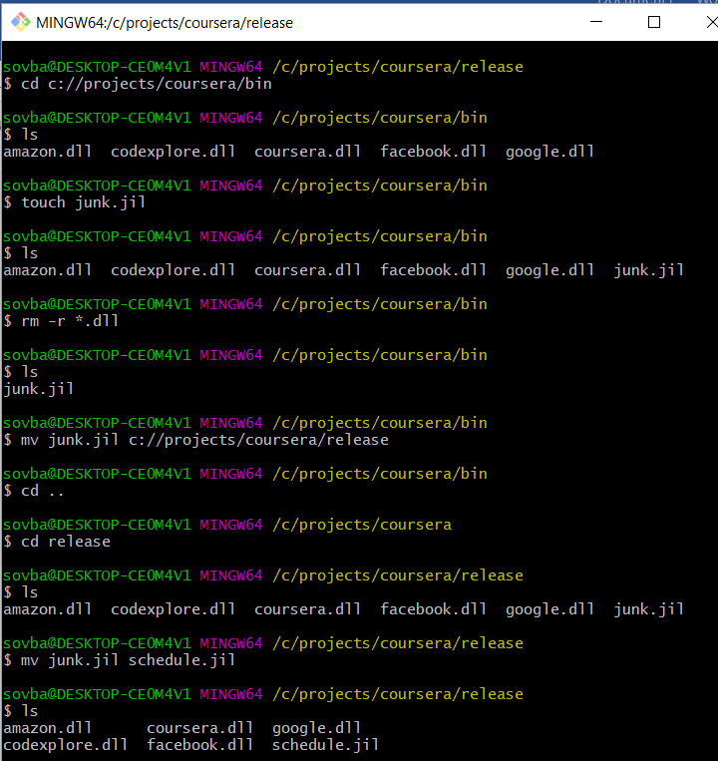

sovba@DESKTOP-CE0M4V1 MINGW64 ~

$ cd c://projects

sovba@DESKTOP-CE0M4V1 MINGW64 /c/projects

$ mkdir coursera

sovba@DESKTOP-CE0M4V1 MINGW64 /c/projects

$ cd courseera

bash: cd: courseera: No such file or directory

sovba@DESKTOP-CE0M4V1 MINGW64 /c/projects

$ coursera

bash: coursera: command not found

sovba@DESKTOP-CE0M4V1 MINGW64 /c/projects

$ cd sclear

bash: cd: sclear: No such file or directory

sovba@DESKTOP-CE0M4V1 MINGW64 /c/projects

$ clear

sovba@DESKTOP-CE0M4V1 MINGW64 /c/projects

$ cd c://projects/coursera

sovba@DESKTOP-CE0M4V1 MINGW64 /c/projects/coursera

$ mkdir bin

sovba@DESKTOP-CE0M4V1 MINGW64 /c/projects/coursera

$ mkdir release

sovba@DESKTOP-CE0M4V1 MINGW64 /c/projects/coursera

$ cd bin

sovba@DESKTOP-CE0M4V1 MINGW64 /c/projects/coursera/bin

$ touch facebook.dll

sovba@DESKTOP-CE0M4V1 MINGW64 /c/projects/coursera/bin

$ codexplore.dll

bash: codexplore.dll: command not found

sovba@DESKTOP-CE0M4V1 MINGW64 /c/projects/coursera/bin

$ touch codexplore.dll

sovba@DESKTOP-CE0M4V1 MINGW64 /c/projects/coursera/bin

$ touch amazon.dll

sovba@DESKTOP-CE0M4V1 MINGW64 /c/projects/coursera/bin

$ touch google.dll

sovba@DESKTOP-CE0M4V1 MINGW64 /c/projects/coursera/bin

$ touch coursera.dll

sovba@DESKTOP-CE0M4V1 MINGW64 /c/projects/coursera/bin

$ cp \*.dll c://projects/coursera/release

sovba@DESKTOP-CE0M4V1 MINGW64 /c/projects/coursera/bin

$ cd c://projects/coursera/release

sovba@DESKTOP-CE0M4V1 MINGW64 /c/projects/coursera/release

$ ls

amazon.dll codexplore.dll coursera.dll facebook.dll google.dll

sovba@DESKTOP-CE0M4V1 MINGW64 /c/projects/coursera/release

$ echo done

done

sovba@DESKTOP-CE0M4V1 MINGW64 /c/projects/coursera/release

$ echo basic git commands

basic git commands

sovba@DESKTOP-CE0M4V1 MINGW64 /c/projects/coursera/release

$ ping www.google.com

Pinging www.google.com [172.217.1.4] with 32 bytes of data:

Reply from 172.217.1.4: bytes=32 time=112ms TTL=55

Request timed out.

Reply from 172.217.1.4: bytes=32 time=15ms TTL=55

Reply from 172.217.1.4: bytes=32 time=15ms TTL=55

Ping statistics for 172.217.1.4:

Packets: Sent = 4, Received = 3, Lost = 1 (25% loss),

Approximate round trip times in milli-seconds:

Minimum = 15ms, Maximum = 112ms, Average = 47ms

sovba@DESKTOP-CE0M4V1 MINGW64 /c/projects/coursera/release

$ touch unittest.com.dll

sovba@DESKTOP-CE0M4V1 MINGW64 /c/projects/coursera/release

$ ls

amazon.dll coursera.dll google.dll

codexplore.dll facebook.dll unittest.com.dll

sovba@DESKTOP-CE0M4V1 MINGW64 /c/projects/coursera/release

$ rm unittest.com.dll

sovba@DESKTOP-CE0M4V1 MINGW64 /c/projects/coursera/release

$ ls

amazon.dll codexplore.dll coursera.dll facebook.dll google.dll

sovba@DESKTOP-CE0M4V1 MINGW64 /c/projects/coursera/release

$ cd c://projects/coursera/build

bash: cd: c://projects/coursera/build: No such file or directory

sovba@DESKTOP-CE0M4V1 MINGW64 /c/projects/coursera/release

$ cd c://projects/coursera/bin

sovba@DESKTOP-CE0M4V1 MINGW64 /c/projects/coursera/bin

$ ls

amazon.dll codexplore.dll coursera.dll facebook.dll google.dll

sovba@DESKTOP-CE0M4V1 MINGW64 /c/projects/coursera/bin

$ touch junk.jil

sovba@DESKTOP-CE0M4V1 MINGW64 /c/projects/coursera/bin

$ ls

amazon.dll codexplore.dll coursera.dll facebook.dll google.dll junk.jil

sovba@DESKTOP-CE0M4V1 MINGW64 /c/projects/coursera/bin

$ rm -r \*.dll

sovba@DESKTOP-CE0M4V1 MINGW64 /c/projects/coursera/bin

$ ls

junk.jil

sovba@DESKTOP-CE0M4V1 MINGW64 /c/projects/coursera/bin

$ mv junk.jil c://projects/coursera/release

sovba@DESKTOP-CE0M4V1 MINGW64 /c/projects/coursera/bin

$ cd ..

sovba@DESKTOP-CE0M4V1 MINGW64 /c/projects/coursera

$ cd release

sovba@DESKTOP-CE0M4V1 MINGW64 /c/projects/coursera/release

$ ls

amazon.dll codexplore.dll coursera.dll facebook.dll google.dll junk.jil

sovba@DESKTOP-CE0M4V1 MINGW64 /c/projects/coursera/release

$ mv junk.jil schedule.jil

sovba@DESKTOP-CE0M4V1 MINGW64 /c/projects/coursera/release

$ ls

amazon.dll coursera.dll google.dll

codexplore.dll facebook.dll schedule.jil

sovba@DESKTOP-CE0M4V1 MINGW64 /c/projects/coursera/release

$ echo date

date

sovba@DESKTOP-CE0M4V1 MINGW64 /c/projects/coursera/release

$ date

Tue, Mar 27, 2018 9:41:28 PM

sovba@DESKTOP-CE0M4V1 MINGW64 /c/projects/coursera/release

$